Name: Arpit Mahalle
Day 25 Assignment output screenshots
Challenge 1 and 2:
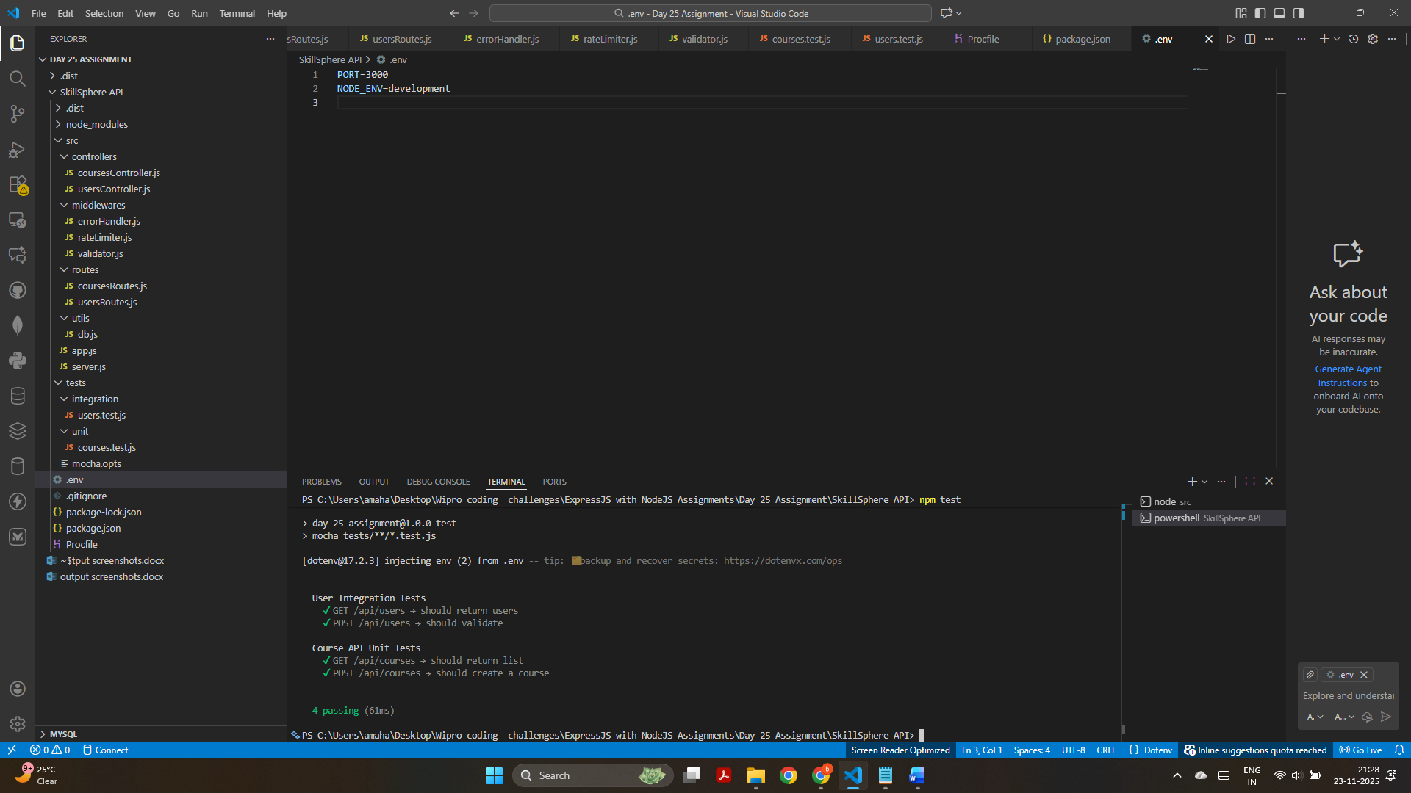
Challenge 1: The unit tests for /api/courses ran successfully, confirming that the GET route returns the course list and the POST route correctly creates a new course. All Course API unit test cases passed.
Challenge 2: The integration tests for /api/users passed, verifying that the GET route returns users and the POST route correctly validates missing fields. Both User API integration test cases passed.

Challenge 3:
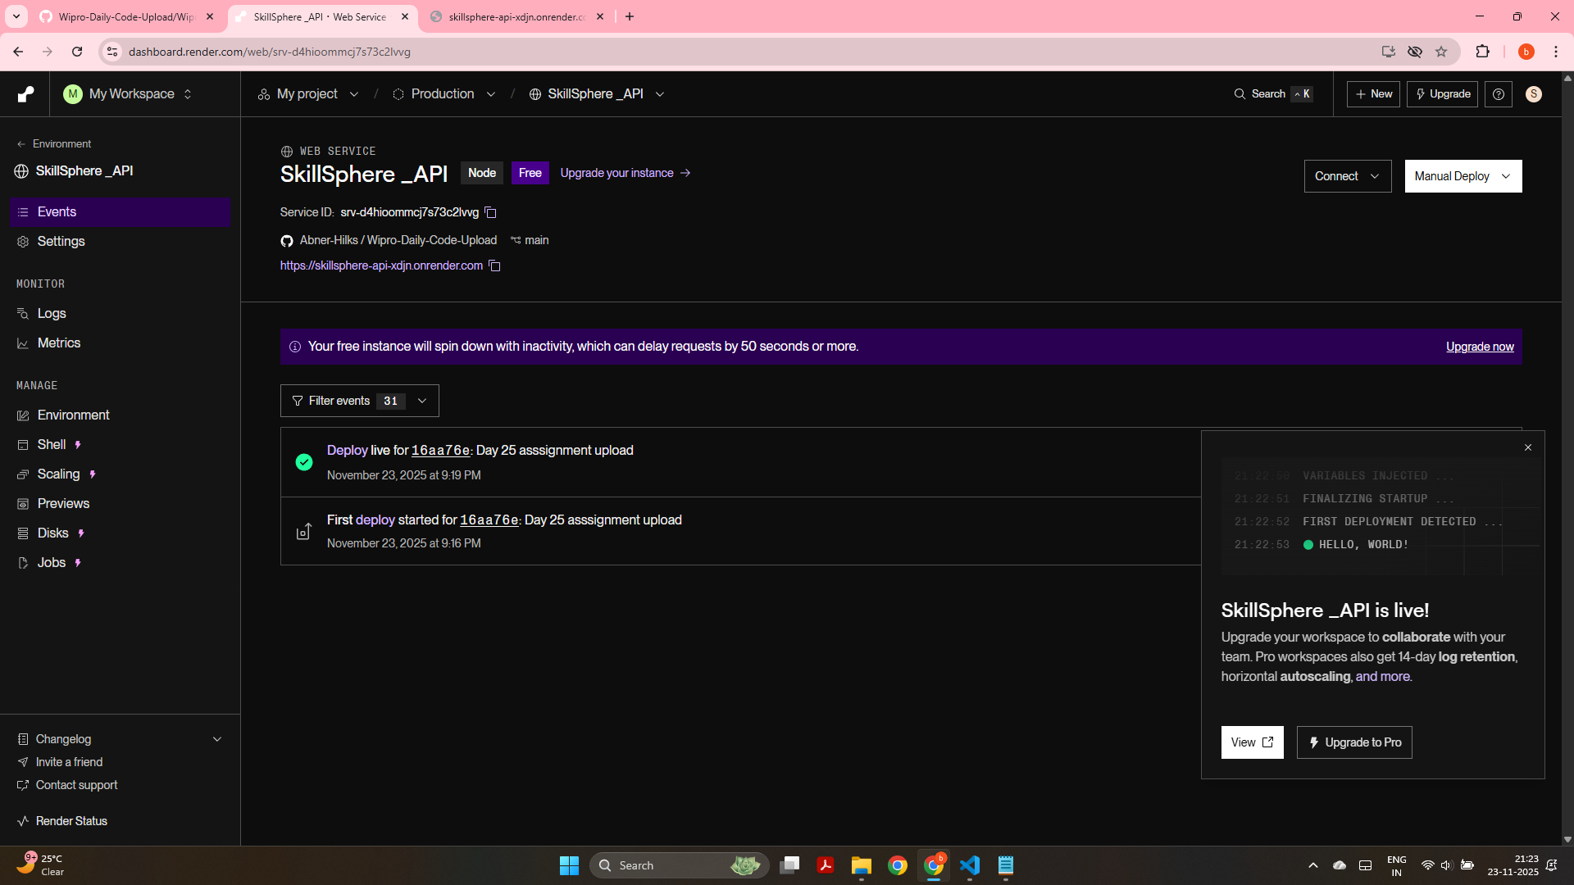
This screenshot shows that the “SkillSphere_API” has been successfully deployed on Render, and the instance has started without any errors.

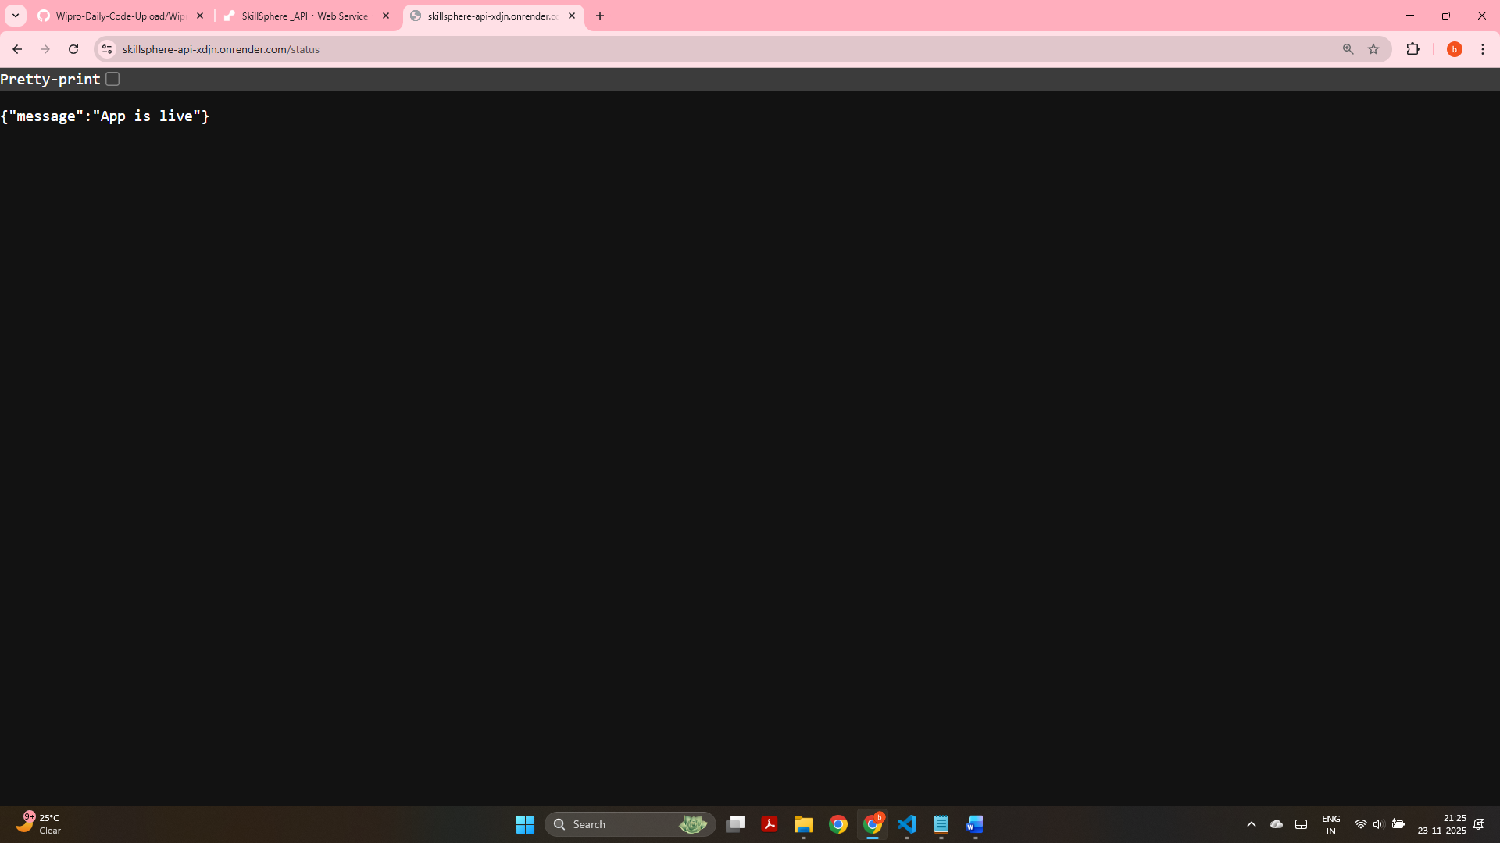
This screenshot confirms that the deployed API is working correctly on Render, with the /status route returning “App is live”.

Link for deployment: https://skillsphere-api-xdjn.onrender.com/status

